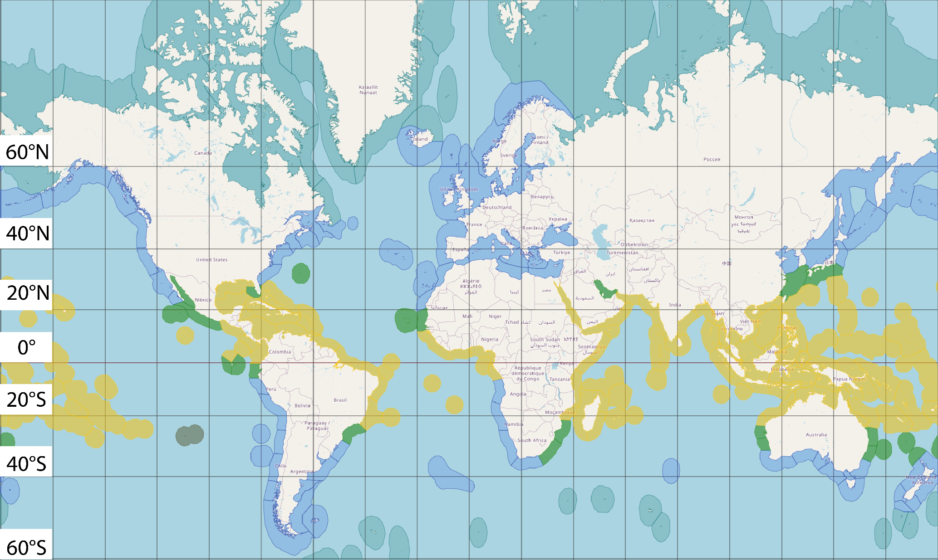

Figure 3 Map showing tropical ecoregions (Yellow), subtropical ecoregions (Green), temperate ecoregions (Blue) and arctic ecoregions (Light Blue), created using R package leaflet.